Topik 1: Konsep Dasar Memori
Teori Singkat
Memori utama (main memory) adalah tempat penyimpanan yang dapat diakses langsung oleh CPU. Dalam sistem operasi, manajemen memori meliputi:
Address Binding: Proses pemetaan alamat logis ke alamat fisik
Logical vs Physical Address: Alamat yang digunakan program vs alamat sebenarnya di RAM Memory Protection: Melindungi area memori antar proses
Praktik 1: Memahami Address Space

File: background/address_demo.c
#include <stdio.h>
#include <stdlib.h>
#include <unistd.h> // untuk getpid()

int global_var = 100; // Data Segment
int uninitialized_var; // BSS Segment

void print_addresses() {
int local_var = 50; // Stack
int *heap_var = (int*)malloc(sizeof(int)); // Heap
*heap_var = 75;

printf("=== MEMORY ADDRESS LAYOUT ===\n\n");

printf("1. Text Segment (Code):\n");
printf(" Function address : %p\n\n", (void*)print_addresses);

printf("2. Data Segment (Initialized Global):\n");
printf(" global_var address : %p, value = %d\n\n",
(void*)&global_var, global_var);

printf("3. BSS Segment (Uninitialized Global):\n");
printf(" uninitialized_var addr: %p, value = %d\n\n",
(void*)&uninitialized_var, uninitialized_var);

printf("4. Heap Segment (Dynamic Allocation):\n");
printf(" heap_var address : %p, value = %d\n\n",
(void*)heap_var, *heap_var);

printf("5. Stack Segment (Local Variable):\n");
printf(" local_var address : %p, value = %d\n\n",
(void*)&local_var, local_var);

free(heap_var);
}

int main() {
char cmd[100];

printf("Program dimulai...\n");
printf("PID: %d\n\n", getpid());

print_addresses();

printf("Tekan Enter untuk melihat memory map...");
getchar();

sprintf(cmd, "cat /proc/%d/maps", getpid());
system(cmd);

return 0;
}

Topik 2: Contiguous Memory Allocation
Teori Singkat
Alokasi memori berurutan membagi memori menjadi beberapa partisi. Ada tiga algoritma utama:

First-Fit: Alokasi pada hole pertama yang cukup besar Best-Fit: Alokasi pada hole terkecil yang cukup besar Worst-Fit: Alokasi pada hole terbesar
Praktik 2: Simulasi Algoritma Alokasi Memori
#include <stdio.h>
#include <stdlib.h>

#define MAX_BLOCKS 10
#define MEMORY_SIZE 1000

typedef struct {
int id;
int size;
int start_address;
int is_allocated;
} MemoryBlock;

MemoryBlock memory[MAX_BLOCKS];
int block_count;

/* ================== UTILITAS MEMORI ================== */

void initialize_memory() {
memory[0].id = -1;
memory[0].size = MEMORY_SIZE;
memory[0].start_address = 0;
memory[0].is_allocated = 0;
block_count = 1;
}

void display_memory() {
printf("\n%-5s %-10s %-15s %-10s\n",
"ID", "Size", "StartAddr", "Status");

for (int i = 0; i < block_count; i++) {
printf("%-5d %-10d %-15d %-10s\n",
memory[i].id,
memory[i].size,
memory[i].start_address,
memory[i].is_allocated ? "Used" : "Free");
}
}

/* ================== ALGORITMA ALOKASI ================== */

int first_fit(int pid, int size) {
for (int i = 0; i < block_count; i++) {
if (!memory[i].is_allocated && memory[i].size >= size) {

int old_size = memory[i].size;
int old_start = memory[i].start_address;

memory[i].id = pid;
memory[i].size = size;
memory[i].is_allocated = 1;

if (old_size > size) {
for (int j = block_count; j > i + 1; j--)
memory[j] = memory[j - 1];

memory[i + 1].id = -1;
memory[i + 1].size = old_size - size;
memory[i + 1].start_address = old_start + size;
memory[i + 1].is_allocated = 0;
block_count++;
}

printf("First-Fit : P%d (%d bytes) @ %d\n",
pid, size, old_start);
return 1;
}
}
return 0;
}

int best_fit(int pid, int size) {
int best = -1, min = MEMORY_SIZE + 1;

for (int i = 0; i < block_count; i++) {
if (!memory[i].is_allocated && memory[i].size >= size) {
if (memory[i].size < min) {
min = memory[i].size;
best = i;
}
}
}

if (best == -1) return 0;

int old_size = memory[best].size;
int old_start = memory[best].start_address;

memory[best].id = pid;
memory[best].size = size;
memory[best].is_allocated = 1;

if (old_size > size) {
for (int j = block_count; j > best + 1; j--)
memory[j] = memory[j - 1];

memory[best + 1].id = -1;
memory[best + 1].size = old_size - size;
memory[best + 1].start_address = old_start + size;
memory[best + 1].is_allocated = 0;
block_count++;
}

printf("Best-Fit : P%d (%d bytes) @ %d\n",
pid, size, old_start);
return 1;
}

int worst_fit(int pid, int size) {
int worst = -1, max = -1;

for (int i = 0; i < block_count; i++) {
if (!memory[i].is_allocated && memory[i].size >= size) {
if (memory[i].size > max) {
max = memory[i].size;
worst = i;
}
}
}

if (worst == -1) return 0;

int old_size = memory[worst].size;
int old_start = memory[worst].start_address;

memory[worst].id = pid;
memory[worst].size = size;
memory[worst].is_allocated = 1;

if (old_size > size) {
for (int j = block_count; j > worst + 1; j--)
memory[j] = memory[j - 1];

memory[worst + 1].id = -1;
memory[worst + 1].size = old_size - size;
memory[worst + 1].start_address = old_start + size;
memory[worst + 1].is_allocated = 0;
block_count++;
}

printf("Worst-Fit : P%d (%d bytes) @ %d\n",
pid, size, old_start);
return 1;
}

/* ================== DEALOKASI ================== */

void deallocate(int pid) {
for (int i = 0; i < block_count; i++) {
if (memory[i].id == pid && memory[i].is_allocated) {
memory[i].id = -1;
memory[i].is_allocated = 0;

if (i + 1 < block_count && !memory[i + 1].is_allocated) {
memory[i].size += memory[i + 1].size;
for (int j = i + 1; j < block_count - 1; j++)
memory[j] = memory[j + 1];
block_count--;
}

if (i > 0 && !memory[i - 1].is_allocated) {
memory[i - 1].size += memory[i].size;
for (int j = i; j < block_count - 1; j++)
memory[j] = memory[j + 1];
block_count--;
}
return;
}
}
}

/* ================== PENGUJIAN ================== */

void run_test(int algo) {
int p[][2] = {{1,100},{2,200},{3,300},{4,150}};

initialize_memory();

for (int i = 0; i < 4; i++) {
if (algo == 1) first_fit(p[i][0], p[i][1]);
if (algo == 2) best_fit(p[i][0], p[i][1]);
if (algo == 3) worst_fit(p[i][0], p[i][1]);
}

display_memory();

deallocate(2);
printf("\nDealokasi P2\n");
display_memory();

if (algo == 1) first_fit(5, 180);
if (algo == 2) best_fit(5, 180);
if (algo == 3) worst_fit(5, 180);

printf("\nAlokasi P5 (180 bytes)\n");
display_memory();
}

/* ================== MAIN ================== */

int main() {
int choice;

while (1) {
printf("\n=== SIMULASI CONTIGUOUS MEMORY ===\n");
printf("1. First-Fit\n");
printf("2. Best-Fit\n");
printf("3. Worst-Fit\n");
printf("4. Jalankan Semua Algoritma\n");
printf("5. Exit\n");
printf("Pilihan: ");
scanf("%d", &choice);

if (choice == 5) break;

if (choice == 4) {
for (int i = 1; i <= 3; i++) {
printf("\n================================\n");
if (i == 1) printf("FIRST-FIT\n");
if (i == 2) printf("BEST-FIT\n");
if (i == 3) printf("WORST-FIT\n");
printf("================================\n");
run_test(i);
}
} else if (choice >= 1 && choice <= 3) {
run_test(choice);
}
}

return 0;
}
Topik 3: Paging
Teori Singkat
Paging membagi memori fisik menjadi frame berukuran tetap dan memori logis menjadi page dengan ukuran sama. Keuntungan:
Menghilangkan external fragmentation Tidak perlu alokasi berurutan
Praktik 3: Simulasi Paging System
#include <stdio.h>
#include <stdlib.h>
#include <string.h>

#define FRAME_SIZE 256 // Ukuran frame (bytes)
#define NUM_FRAMES 16 // Jumlah frame fisik
#define PAGE_SIZE FRAME_SIZE

typedef struct {
int page_number;
int frame_number;
int valid;
int reference_bit;
int modify_bit;
} PageTableEntry;

typedef struct {
int occupied;
int page_number;
} Frame;

Frame physical_memory[NUM_FRAMES];
PageTableEntry page_table[100];
int num_pages = 0;

/* ================= INITIALIZATION ================= */
void initialize_system() {
for (int i = 0; i < NUM_FRAMES; i++) {
physical_memory[i].occupied = 0;
physical_memory[i].page_number = -1;
}

for (int i = 0; i < 100; i++) {
page_table[i].page_number = i;
page_table[i].frame_number = -1;
page_table[i].valid = 0;
page_table[i].reference_bit = 0;
page_table[i].modify_bit = 0;
}

printf("\nSistem paging diinisialisasi\n");
printf("Frame size : %d bytes\n", FRAME_SIZE);
printf("Number of frames : %d\n", NUM_FRAMES);
printf("Total physical memory : %d bytes\n\n", FRAME_SIZE * NUM_FRAMES);
}

/* ================= DISPLAY ================= */
void display_page_table() {
printf("\n=== PAGE TABLE ===\n");
printf("%-10s %-10s %-8s %-10s %-10s\n",
"Page", "Frame", "Valid", "Ref", "Mod");
printf("---------------------------------------------\n");

for (int i = 0; i < num_pages; i++) {
printf("%-10d %-10d %-8s %-10s %-10s\n",
page_table[i].page_number,
page_table[i].frame_number,
page_table[i].valid ? "Yes" : "No",
page_table[i].reference_bit ? "Yes" : "No",
page_table[i].modify_bit ? "Yes" : "No");
}
}

void display_physical_memory() {
printf("\n=== PHYSICAL MEMORY ===\n");
printf("%-10s %-10s %-10s\n", "Frame", "Status", "Page");

for (int i = 0; i < NUM_FRAMES; i++) {
printf("%-10d %-10s",
i,
physical_memory[i].occupied ? "Used" : "Free");

if (physical_memory[i].occupied)
printf("%-10d", physical_memory[i].page_number);

printf("\n");
}
}

/* ================= CORE LOGIC ================= */
int find_free_frame() {
for (int i = 0; i < NUM_FRAMES; i++)
if (!physical_memory[i].occupied)
return i;
return -1;
}

int allocate_page(int page_num) {
if (page_num >= 100) {
printf("Error: Page terlalu besar\n");
return -1;
}

if (page_table[page_num].valid) {
printf("Page %d sudah ada di frame %d\n",
page_num, page_table[page_num].frame_number);
page_table[page_num].reference_bit = 1;
return page_table[page_num].frame_number;
}

int frame = find_free_frame();
if (frame == -1) {
printf("PAGE FAULT: Tidak ada frame kosong\n");
return -1;
}

page_table[page_num].frame_number = frame;
page_table[page_num].valid = 1;
page_table[page_num].reference_bit = 1;

physical_memory[frame].occupied = 1;
physical_memory[frame].page_number = page_num;

if (page_num >= num_pages)
num_pages = page_num + 1;

printf("Page %d dialokasikan ke frame %d\n", page_num, frame);
return frame;
}

int translate_address(int logical_address) {
int page_num = logical_address / PAGE_SIZE;
int offset = logical_address % PAGE_SIZE;

printf("\nLogical Address : %d\n", logical_address);
printf("Page Number : %d\n", page_num);
printf("Offset : %d\n", offset);

if (page_num >= num_pages || !page_table[page_num].valid) {
printf("PAGE FAULT → alokasi page\n");
if (allocate_page(page_num) == -1)
return -1;
}

int frame = page_table[page_num].frame_number;
int physical_address = frame * FRAME_SIZE + offset;

page_table[page_num].reference_bit = 1;

printf("Physical Address: %d\n", physical_address);
return physical_address;
}

void access_memory(int logical_address, int write) {
printf("\n=== MEMORY ACCESS (%s) ===\n", write ? "WRITE" : "READ");

int physical = translate_address(logical_address);
if (physical != -1 && write) {
int page = logical_address / PAGE_SIZE;
page_table[page].modify_bit = 1;
printf("Page %d ditandai MODIFIED\n", page);
}
}

/* ================= DEMO ================= */
void demo_scenario() {
printf("\n=== DEMO PAGING SYSTEM ===\n");

access_memory(0, 0);
access_memory(300, 1);
access_memory(512, 0);
access_memory(100, 0);
access_memory(1024, 1);

display_page_table();
display_physical_memory();
}

/* ================= MAIN ================= */
int main() {
int choice, addr;
initialize_system();

while (1) {
printf("\n=== PAGING SIMULATOR ===\n");
printf("1. Allocate Page\n");
printf("2. Translate Address\n");
printf("3. Read Memory\n");
printf("4. Write Memory\n");
printf("5. Display Page Table\n");
printf("6. Display Physical Memory\n");
printf("7. Run Demo Scenario\n");
printf("8. Reset System\n");
printf("9. Exit\n");
printf("Pilihan: ");
scanf("%d", &choice);

switch (choice) {
case 1:
printf("Page number: ");
scanf("%d", &addr);
allocate_page(addr);
break;

case 2:
printf("Logical address: ");
scanf("%d", &addr);
translate_address(addr);
break;

case 3:
printf("Logical address: ");
scanf("%d", &addr);
access_memory(addr, 0);
break;

case 4:
printf("Logical address: ");
scanf("%d", &addr);
access_memory(addr, 1);
break;

case 5:
display_page_table();
break;

case 6:
display_physical_memory();
break;

case 7:
demo_scenario();
break;

case 8:
num_pages = 0;
initialize_system();
break;

case 9:
printf("Program selesai\n");
return 0;
}
}
}

Topik 4: Structure of The Page Table
Teori Singkat
Struktur page table mempengaruhi efisiensi akses memori:

Hierarchical Paging: Page table multi-level
Hashed Page Table: Menggunakan hash function
Inverted Page Table: Satu entry per frame (bukan per page)
Praktik 4: Two-Level Page Table
File: page-table/two_level_paging.c
#include <stdio.h>
#include <stdlib.h>
#include <math.h>

/* ================= KONFIGURASI SISTEM ================= */

#define PAGE_SIZE 4096 // 4 KB
#define VIRTUAL_ADDR_BITS 32
#define OFFSET_BITS 12 // log2(4096)
#define OUTER_PAGE_BITS 10
#define INNER_PAGE_BITS 10

/* ================= STRUKTUR DATA ================= */

typedef struct {
int frame_number;
int valid;
} InnerPageTableEntry;

typedef struct {
InnerPageTableEntry *inner_table;
int valid;
} OuterPageTableEntry;

/* ================= VARIABEL GLOBAL ================= */

OuterPageTableEntry *outer_page_table;
int num_outer_entries;
int num_inner_entries;

/* ================= INISIALISASI ================= */

void initialize_two_level_paging() {
num_outer_entries = (int)pow(2, OUTER_PAGE_BITS);
num_inner_entries = (int)pow(2, INNER_PAGE_BITS);

outer_page_table = (OuterPageTableEntry *)
calloc(num_outer_entries, sizeof(OuterPageTableEntry));

printf("\n=== TWO-LEVEL PAGE TABLE INITIALIZED ===\n");
printf("Virtual Address : %d-bit\n", VIRTUAL_ADDR_BITS);
printf("Page Size : %d bytes\n", PAGE_SIZE);
printf("Outer Entries : %d\n", num_outer_entries);
printf("Inner Entries : %d\n", num_inner_entries);
printf("Offset Bits : %d\n", OFFSET_BITS);
printf("======================================\n");
}

/* ================= PARSING ADDRESS ================= */

void parse_virtual_address(unsigned int vaddr,
int *outer, int *inner, int *offset) {
*offset = vaddr & ((1 << OFFSET_BITS) - 1);
*inner = (vaddr >> OFFSET_BITS) & ((1 << INNER_PAGE_BITS) - 1);
*outer = (vaddr >> (OFFSET_BITS + INNER_PAGE_BITS)) &
((1 << OUTER_PAGE_BITS) - 1);
}

/* ================= ALOKASI PAGE ================= */

void allocate_page_two_level(unsigned int vaddr, int frame) {
int outer, inner, offset;
parse_virtual_address(vaddr, &outer, &inner, &offset);

printf("\nAllocating Virtual Address: 0x%08X\n", vaddr);
printf("Outer Index: %d | Inner Index: %d\n", outer, inner);

if (!outer_page_table[outer].valid) {
outer_page_table[outer].inner_table =
(InnerPageTableEntry *)
calloc(num_inner_entries, sizeof(InnerPageTableEntry));
outer_page_table[outer].valid = 1;
printf("✓ Inner page table dibuat\n");
}

outer_page_table[outer].inner_table[inner].frame_number = frame;
outer_page_table[outer].inner_table[inner].valid = 1;

printf("✓ Page dialokasikan ke frame %d\n", frame);
}

/* ================= TRANSLASI ALAMAT ================= */

int translate_address_two_level(unsigned int vaddr) {
int outer, inner, offset;
parse_virtual_address(vaddr, &outer, &inner, &offset);

printf("\n--- ADDRESS TRANSLATION ---\n");
printf("Virtual Address : 0x%08X\n", vaddr);
printf("Outer Index : %d\n", outer);
printf("Inner Index : %d\n", inner);
printf("Offset : %d\n", offset);

if (!outer_page_table[outer].valid) {
printf("✗ PAGE FAULT (Outer Table)\n");
return -1;
}

InnerPageTableEntry *inner_table =
outer_page_table[outer].inner_table;

if (!inner_table[inner].valid) {
printf("✗ PAGE FAULT (Inner Table)\n");
return -1;
}

int frame = inner_table[inner].frame_number;
int physical = frame * PAGE_SIZE + offset;

printf("Frame Number : %d\n", frame);
printf("Physical Addr : %d\n", physical);
printf("✓ Translation SUCCESS\n");

return physical;
}

/* ================= TAMPILKAN PAGE TABLE ================= */

void display_page_table_two_level() {
printf("\n=== TWO-LEVEL PAGE TABLE ===\n");

for (int i = 0; i < num_outer_entries; i++) {
if (outer_page_table[i].valid) {
printf("Outer[%d] VALID\n", i);
InnerPageTableEntry *inner = outer_page_table[i].inner_table;
for (int j = 0; j < num_inner_entries; j++) {
if (inner[j].valid) {
printf(" Inner[%d] -> Frame %d\n",
j, inner[j].frame_number);
}
}
}
}
}

/* ================= OVERHEAD ================= */

void calculate_overhead() {
long single_level =
(long)pow(2, 20) * sizeof(InnerPageTableEntry);

long two_level_min =
num_outer_entries * sizeof(OuterPageTableEntry) +
num_inner_entries * sizeof(InnerPageTableEntry);

printf("\n=== MEMORY OVERHEAD ===\n");
printf("Single-Level Page Table : %.2f MB\n",
single_level / (1024.0 * 1024.0));
printf("Two-Level (Best Case) : %.2f KB\n",
two_level_min / 1024.0);
}

/* ================= DEMO ================= */

void demo_two_level() {
printf("\n===== DEMO TWO-LEVEL PAGING =====\n");

allocate_page_two_level(0x00000000, 10);
allocate_page_two_level(0x00001000, 11);
allocate_page_two_level(0x00400000, 20);
allocate_page_two_level(0x00401000, 21);

display_page_table_two_level();

printf("\n--- TRANSLATION TEST ---\n");
translate_address_two_level(0x00000500); // HIT
translate_address_two_level(0x00002000); // PAGE FAULT
translate_address_two_level(0x00400100); // HIT

calculate_overhead();
}

/* ================= CLEANUP ================= */

void cleanup_two_level() {
for (int i = 0; i < num_outer_entries; i++) {
if (outer_page_table[i].valid) {
free(outer_page_table[i].inner_table);
}
}
free(outer_page_table);
}

/* ================= MAIN ================= */

int main() {
int choice;
unsigned int vaddr;
int frame;

initialize_two_level_paging();

while (1) {
printf("\n=== TWO-LEVEL PAGING SIMULATOR ===\n");
printf("1. Allocate Page\n");
printf("2. Translate Address\n");
printf("3. Display Page Table\n");
printf("4. Calculate Overhead\n");
printf("5. Run Demo\n");
printf("6. Exit\n");
printf("Pilihan: ");
scanf("%d", &choice);

switch (choice) {
case 1:
printf("Virtual Address (hex): ");
scanf("%x", &vaddr);
printf("Frame number: ");
scanf("%d", &frame);
allocate_page_two_level(vaddr, frame);
break;
case 2:
printf("Virtual Address (hex): ");
scanf("%x", &vaddr);
translate_address_two_level(vaddr);
break;
case 3:
display_page_table_two_level();
break;
case 4:
calculate_overhead();
break;
case 5:
demo_two_level();
break;
case 6:
cleanup_two_level();
return 0;
default:
printf("Pilihan tidak valid\n");
}
}
}

Topik 5: Swapping
Teori Singkat
Swapping adalah mekanisme memindahkan proses dari/ke disk storage ketika memori utama penuh. Komponen:
Swap Out: Memindahkan proses dari memory ke disk Swap In: Memindahkan proses dari disk ke memory
Backing Store: Area di disk untuk menyimpan proses yang di-swap

Praktik 5: Simulasi Swapping Mechanism

File: swapping/swap_simulator.c
#include <stdio.h>
#include <stdlib.h>
#include <unistd.h>

#define PAGE_SIZE 256
#define LOGICAL_MEMORY 2048
#define NUM_PAGES (LOGICAL_MEMORY / PAGE_SIZE)
#define NUM_FRAMES 4

int page_table[NUM_PAGES];
int frame_used[NUM_FRAMES];
int next_frame = 0;

/* ================= PAGING ================= */

void init_paging() {
for (int i = 0; i < NUM_PAGES; i++)
page_table[i] = -1;
for (int i = 0; i < NUM_FRAMES; i++)
frame_used[i] = 0;
next_frame = 0;
}

void access_logical_address(int logical_address) {
int page = logical_address / PAGE_SIZE;
int offset = logical_address % PAGE_SIZE;

printf("\nLogical Address: %d\n", logical_address);
printf("Page Number : %d\n", page);
printf("Offset : %d\n", offset);

if (page_table[page] == -1) {
printf("⚠ PAGE FAULT terjadi!\n");

if (next_frame >= NUM_FRAMES) {
printf("✗ Tidak ada frame kosong, simulasi sederhana berhenti\n");
return;
}

page_table[page] = next_frame;
frame_used[next_frame] = 1;
printf("✓ Page %d dimuat ke Frame %d\n", page, next_frame);
next_frame++;
}

int physical_address = page_table[page] * PAGE_SIZE + offset;
printf("Physical Address: %d\n", physical_address);
}

/* ================= DEMO ================= */

void demo_paging() {
printf("\n═══════════════════════════════════════\n");
printf(" DEMO SCENARIO – PAGING SYSTEM\n");
printf("═══════════════════════════════════════\n");

init_paging();

int addresses[] = {0, 256, 512, 768};
int n = sizeof(addresses) / sizeof(int);

for (int i = 0; i < n; i++) {
access_logical_address(addresses[i]);
sleep(1);
}

printf("\n=== HITUNG ALAMAT LOGIS ===\n");
int logical = 1500;
int page = logical / PAGE_SIZE;
int offset = logical % PAGE_SIZE;

printf("Logical Address = %d\n", logical);
printf("Page Number = %d\n", page);
printf("Offset = %d\n", offset);
}

/* ================= MENU ================= */

int main() {
int choice;

while (1) {
printf("\n═══════════════════════════════════════\n");
printf(" OS MEMORY SIMULATOR\n");
printf("═══════════════════════════════════════\n");
printf("1. Demo Paging Scenario\n");
printf("2. Akses Alamat Logis Manual\n");
printf("3. Exit\n");
printf("Pilihan: ");
scanf("%d", &choice);

if (choice == 1) {
demo_paging();
}
else if (choice == 2) {
int addr;
printf("Masukkan logical address: ");
scanf("%d", &addr);
access_logical_address(addr);
}
else if (choice == 3) {
printf("Keluar...\n");
break;
}
else {
printf("Pilihan tidak valid\n");
}
}

return 0;
}

Topik 6: Example Intel 32 & 64-Bit Architectures
Teori Singkat
Intel IA-32 (32-bit):

Address space: 4 GB (2³² bytes) Page size: 4 KB atau 4 MB
Two-level paging (4KB pages) atau single-level (4MB pages) Intel x86-64 (64-bit):
Address space: 256 TB (2⁴⁸ bytes praktis)
Page size: 4 KB, 2 MB, atau 1 GB Four-level paging
Praktik 6: Analisis Arsitektur Intel

File: architecture/intel_analysis.sh
#include <stdio.h>
#include <stdlib.h>
#include <string.h>
#include <time.h>
#include <unistd.h>

#define MAX_PROCESSES 20
#define PHYSICAL_MEMORY 1024 // MB
#define SWAP_SPACE 2048 // MB

typedef enum {
NEW, READY, RUNNING, SWAPPED, TERMINATED
} ProcessState;

typedef struct {
int pid;
char name[20];
int size;
int priority;
ProcessState state;
int in_memory;
int swap_location;
time_t load_time;
time_t last_access;
int swap_count;
int access_count;
} Process;

Process processes[MAX_PROCESSES];
int process_count = 0;
int used_memory = 0;
int used_swap = 0;
int total_swap_operations = 0;

/* ================= INITIALIZATION ================= */

void initialize_system() {
process_count = 0;
used_memory = 0;
used_swap = 0;
total_swap_operations = 0;

for (int i = 0; i < MAX_PROCESSES; i++) {
processes[i].pid = -1;
}

printf("\n=== SWAPPING SYSTEM INITIALIZED ===\n");
printf("Physical Memory : %d MB\n", PHYSICAL_MEMORY);
printf("Swap Space : %d MB\n\n", SWAP_SPACE);
}

/* ================= DISPLAY ================= */

void display_memory_status() {
printf("\n=== MEMORY STATUS ===\n");
printf("Physical Memory: %d / %d MB\n", used_memory, PHYSICAL_MEMORY);
printf("Swap Space : %d / %d MB\n", used_swap, SWAP_SPACE);
printf("Total Swaps : %d\n\n", total_swap_operations);

printf("%-3s %-10s %-6s %-8s %-10s %-6s %-6s\n",
"PID","Name","Size","Prio","State","Swap","Acc");

for (int i = 0; i < process_count; i++) {
if (processes[i].pid != -1) {
printf("%-3d %-10s %-6d %-8d %-10s %-6d %-6d\n",
processes[i].pid,
processes[i].name,
processes[i].size,
processes[i].priority,
processes[i].state == READY ? "MEM" :
processes[i].state == SWAPPED ? "SWAP" : "OTHER",
processes[i].swap_count,
processes[i].access_count
);
}
}
}

/* ================= PROCESS ================= */

int create_process(char *name, int size, int priority) {
if (process_count >= MAX_PROCESSES) return -1;

Process *p = &processes[process_count];
p->pid = process_count + 1;
strcpy(p->name, name);
p->size = size;
p->priority = priority;
p->state = NEW;
p->in_memory = 0;
p->swap_location = -1;
p->load_time = time(NULL);
p->last_access = time(NULL);
p->swap_count = 0;
p->access_count = 0;

process_count++;
return p->pid;
}

/* ================= VICTIM SELECTION ================= */

int find_victim_fifo() {
time_t t = time(NULL);
int idx = -1;
for (int i = 0; i < process_count; i++) {
if (processes[i].in_memory && processes[i].load_time < t) {
t = processes[i].load_time;
idx = i;
}
}
return idx;
}

int find_victim_lru() {
time_t t = time(NULL);
int idx = -1;
for (int i = 0; i < process_count; i++) {
if (processes[i].in_memory && processes[i].last_access < t) {
t = processes[i].last_access;
idx = i;
}
}
return idx;
}

int find_victim_priority() {
int pr = 99, idx = -1;
for (int i = 0; i < process_count; i++) {
if (processes[i].in_memory && processes[i].priority < pr) {
pr = processes[i].priority;
idx = i;
}
}
return idx;
}

/* ================= SWAP ================= */

void swap_out(int idx) {
Process *p = &processes[idx];
used_memory -= p->size;
used_swap += p->size;
p->in_memory = 0;
p->state = SWAPPED;
p->swap_count++;
total_swap_operations++;
}

void swap_in(int idx) {
Process *p = &processes[idx];
used_memory += p->size;
used_swap -= p->size;
p->in_memory = 1;
p->state = READY;
p->load_time = time(NULL);
p->last_access = time(NULL);
total_swap_operations++;
}

/* ================= LOAD ================= */

void load_process(int pid, int strategy) {
int idx = pid - 1;

while (used_memory + processes[idx].size > PHYSICAL_MEMORY) {
int victim =
strategy == 1 ? find_victim_fifo() :
strategy == 2 ? find_victim_lru() :
find_victim_priority();
if (victim == -1) return;
swap_out(victim);
}

if (!processes[idx].in_memory)
swap_in(idx);
}

/* ================= ACCESS ================= */

void access_process(int pid) {
Process *p = &processes[pid - 1];
if (!p->in_memory)
load_process(pid, 2);
p->last_access = time(NULL);
p->access_count++;
}

/* ================= DEMO SCENARIO (MENU 8) ================= */

void demo_scenario() {
printf("\n=== DEMO SCENARIO ===\n");

create_process("Chrome", 300, 8);
create_process("VSCode", 250, 7);
create_process("Firefox", 280, 6);
create_process("Spotify", 150, 5);
create_process("Terminal", 50, 9);
create_process("Docker", 400, 7);

load_process(1, 2);
load_process(2, 2);
load_process(3, 2);
load_process(5, 2);

display_memory_status();

access_process(1);
access_process(5);

load_process(6, 2); // trigger swap

display_memory_status();
}

/* ================= MAIN ================= */

int main() {
int choice, pid;
initialize_system();

while (1) {
printf("\n1.Create 2.Load FIFO 3.Load LRU 4.Load Priority\n");
printf("5.Access 6.Status 7.Demo 8.Exit\n");
printf("Choice: ");
scanf("%d", &choice);

if (choice == 8) break;

switch (choice) {
case 1: {
char n[20]; int s, p;
scanf("%s %d %d", n, &s, &p);
create_process(n, s, p);
} break;
case 2: scanf("%d", &pid); load_process(pid, 1); break;
case 3: scanf("%d", &pid); load_process(pid, 2); break;
case 4: scanf("%d", &pid); load_process(pid, 3); break;
case 5: scanf("%d", &pid); access_process(pid); break;
case 6: display_memory_status(); break;
case 7: demo_scenario(); break;
}
}
return 0;
}
Topik 7: Example ARMv8 Architecture

Teori Singkat
ARMv8 Architecture:

Mendukung 32-bit (AArch32) dan 64-bit (AArch64) Virtual address: 48-bit atau 52-bit
Page size: 4KB, 16KB, atau 64KB
Multi-level translation table (hingga 4 level)

Praktik 7: Perbandingan Arsitektur

File: architecture/architecture_comparison.c
#include <stdio.h>
#include <stdlib.h>
#include <math.h>

/* Struktur spesifikasi arsitektur memori */
typedef struct {
char name[40];
int address_bits;
int page_size;
int levels;
int bits_per_level[4];
} ArchitectureSpec;

/* Cetak detail arsitektur */
void print_architecture_details(ArchitectureSpec *arch) {
printf("\n╔════════════════════════════════════════════════╗\n");
printf(" %s\n", arch->name);
printf("╚════════════════════════════════════════════════╝\n");

printf("Address Space : %d bits\n", arch->address_bits);

printf("Maximum Virtual Space: ");
if (arch->address_bits == 32)
printf("4 GB\n");
else if (arch->address_bits == 48)
printf("256 TB\n");
else
printf("2^%d bytes\n", arch->address_bits);

printf("Page Size : %d bytes (%d KB)\n",
arch->page_size, arch->page_size / 1024);

int offset_bits = (int)log2(arch->page_size);
printf("Offset Bits : %d bits\n", offset_bits);

printf("Paging Levels : %d\n", arch->levels);

for (int i = 0; i < arch->levels; i++) {
if (arch->bits_per_level[i] > 0) {
printf(" Level %d: %d bits (%d entries)\n",
i + 1,
arch->bits_per_level[i],
(int)pow(2, arch->bits_per_level[i]));
}
}

/* Address breakdown */
printf("\nAddress Breakdown:\n");
int current_bit = arch->address_bits - 1;

for (int i = 0; i < arch->levels; i++) {
if (arch->bits_per_level[i] > 0) {
printf(" Bits %d-%d : Level %d index (%d bits)\n",
current_bit,
current_bit - arch->bits_per_level[i] + 1,
i + 1,
arch->bits_per_level[i]);
current_bit -= arch->bits_per_level[i];
}
}

printf(" Bits %d-0 : Page Offset (%d bits)\n",
offset_bits - 1, offset_bits);

/* Memory overhead (worst-case theoretical) */
printf("\nMemory Overhead (Worst Case – Page Tables):\n");

double total_entries = 1.0;

for (int i = 0; i < arch->levels; i++) {
if (arch->bits_per_level[i] > 0) {
total_entries *= pow(2, arch->bits_per_level[i]);
double size_bytes = total_entries * 8; // asumsi 8 byte per entry

printf(" Level %d cumulative size: ", i + 1);

if (size_bytes < 1024)
printf("%.0f bytes\n", size_bytes);
else if (size_bytes < 1024 * 1024)
printf("%.2f KB\n", size_bytes / 1024.0);
else if (size_bytes < 1024.0 * 1024 * 1024)
printf("%.2f MB\n", size_bytes / (1024.0 * 1024));
else if (size_bytes < 1024.0 * 1024 * 1024 * 1024)
printf("%.2f GB\n", size_bytes / (1024.0 * 1024 * 1024));
else
printf("%.2f TB\n", size_bytes / (1024.0 * 1024 * 1024 * 1024));
}
}
printf("\n");
}

/* Bandingkan beberapa arsitektur */
void compare_architectures() {

ArchitectureSpec ia32 = {
"Intel IA-32 (32-bit)",
32,
4096,
2,
{10, 10, 0, 0}
};

ArchitectureSpec x86_64 = {
"Intel x86-64 (64-bit)",
48,
4096,
4,
{9, 9, 9, 9}
};

ArchitectureSpec armv8_4k = {
"ARMv8 (4 KB Pages)",
48,
4096,
4,
{9, 9, 9, 9}
};

ArchitectureSpec armv8_16k = {
"ARMv8 (16 KB Pages)",
48,
16384,
4,
{1, 11, 11, 11}
};

ArchitectureSpec armv8_64k = {
"ARMv8 (64 KB Pages)",
48,
65536,
3,
{5, 13, 13, 0}
};

printf("╔═══════════════════════════════════════════════════╗\n");
printf(" ARCHITECTURE COMPARISON\n");
printf("╚═══════════════════════════════════════════════════╝\n");

print_architecture_details(&ia32);
print_architecture_details(&x86_64);
print_architecture_details(&armv8_4k);
print_architecture_details(&armv8_16k);
print_architecture_details(&armv8_64k);

printf("╔═══════════════════════════════════════════════════╗\n");
printf(" SUMMARY TABLE\n");
printf("╚═══════════════════════════════════════════════════╝\n");

printf("%-30s %-15s %-15s %-10s\n",
"Architecture", "Address Bits", "Page Size", "Levels");
printf("---------------------------------------------------------------\n");

printf("%-30s %-15d %-15s %-10d\n", ia32.name, ia32.address_bits, "4 KB", ia32.levels);
printf("%-30s %-15d %-15s %-10d\n", x86_64.name, x86_64.address_bits, "4 KB", x86_64.levels);
printf("%-30s %-15d %-15s %-10d\n", armv8_4k.name, armv8_4k.address_bits, "4 KB", armv8_4k.levels);
printf("%-30s %-15d %-15s %-10d\n", armv8_16k.name, armv8_16k.address_bits, "16 KB", armv8_16k.levels);
printf("%-30s %-15d %-15s %-10d\n", armv8_64k.name, armv8_64k.address_bits, "64 KB", armv8_64k.levels);
}

int main() {
compare_architectures();
return 0;
}

1.1
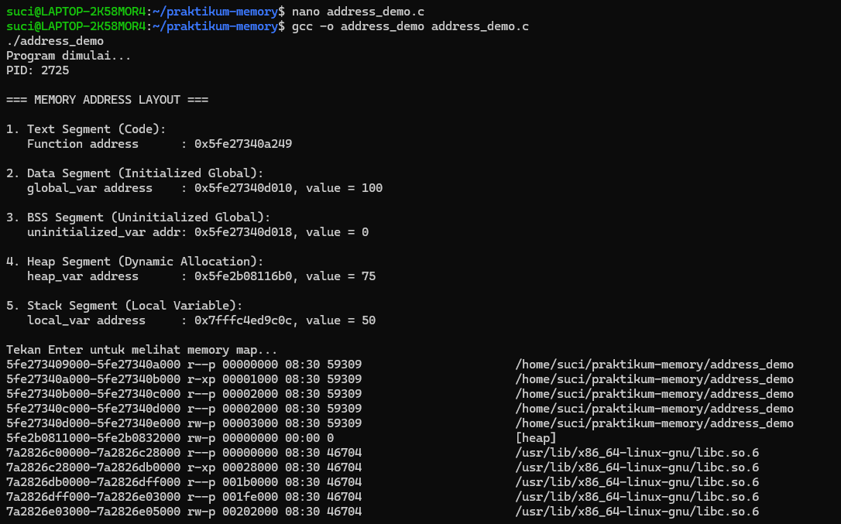
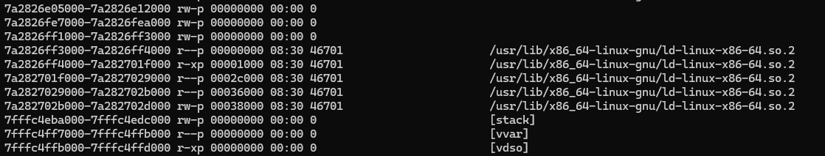
1.2
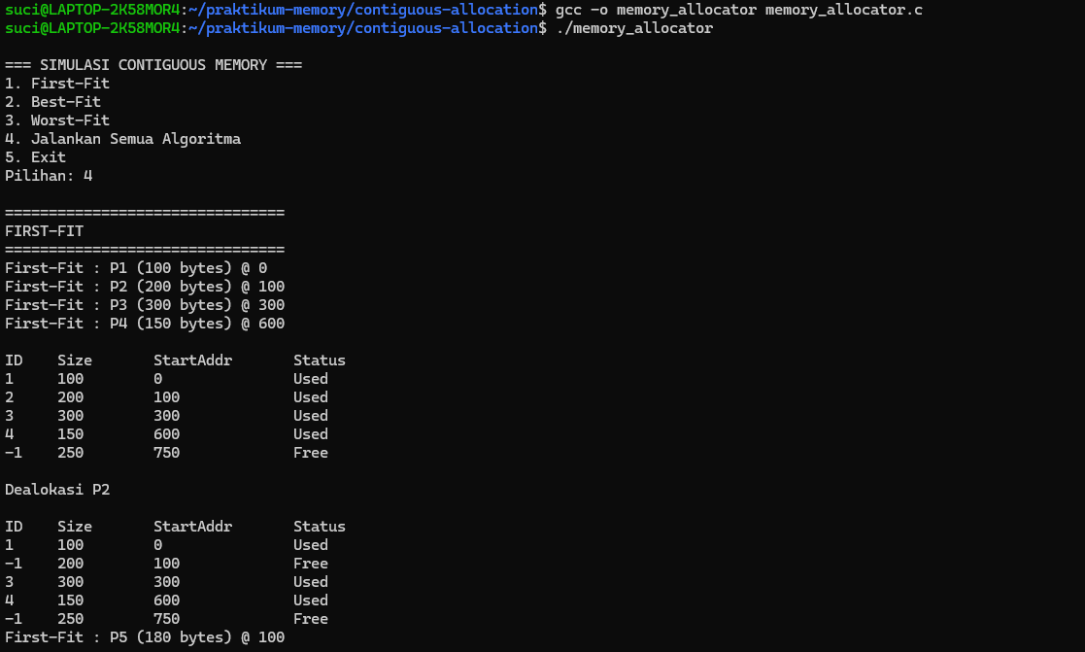
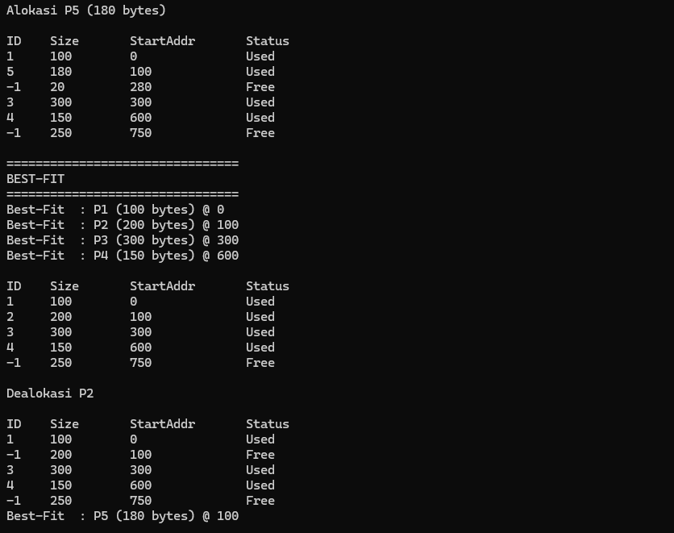
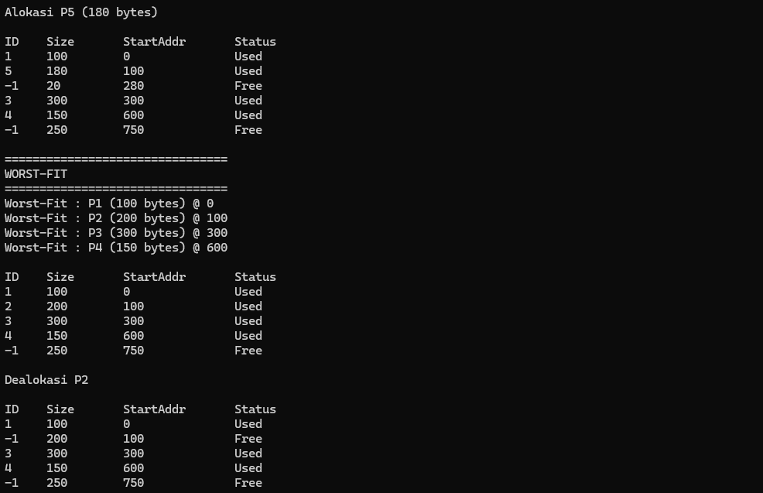
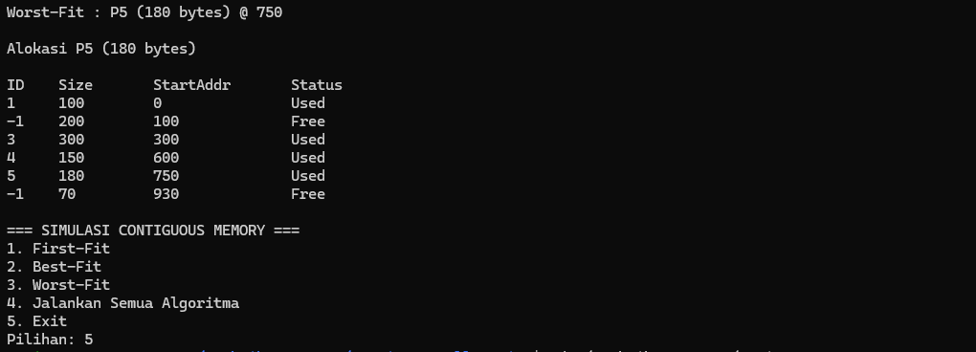
1.3
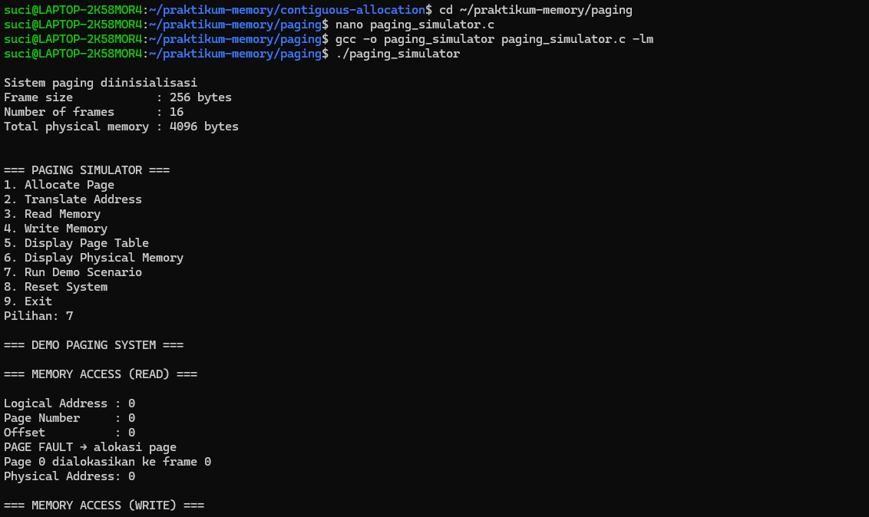
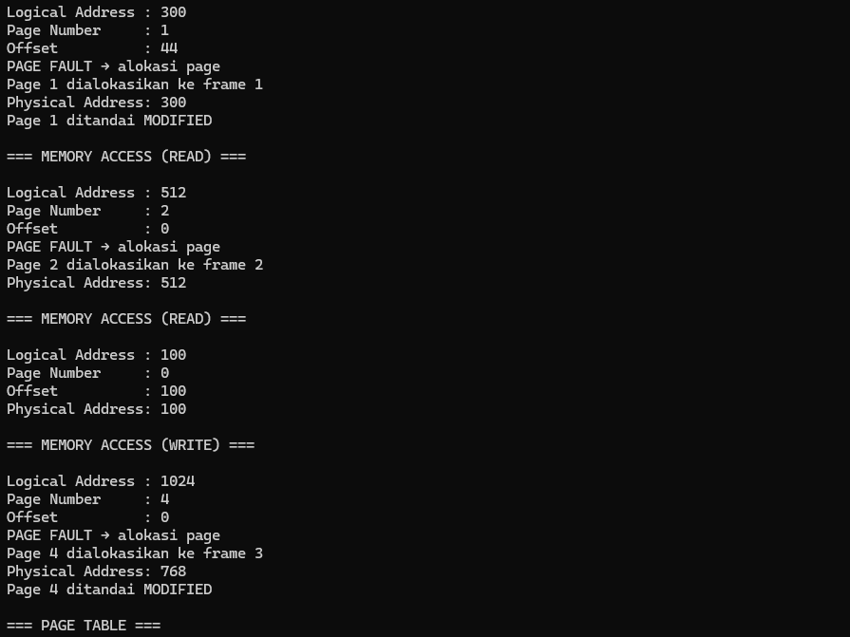
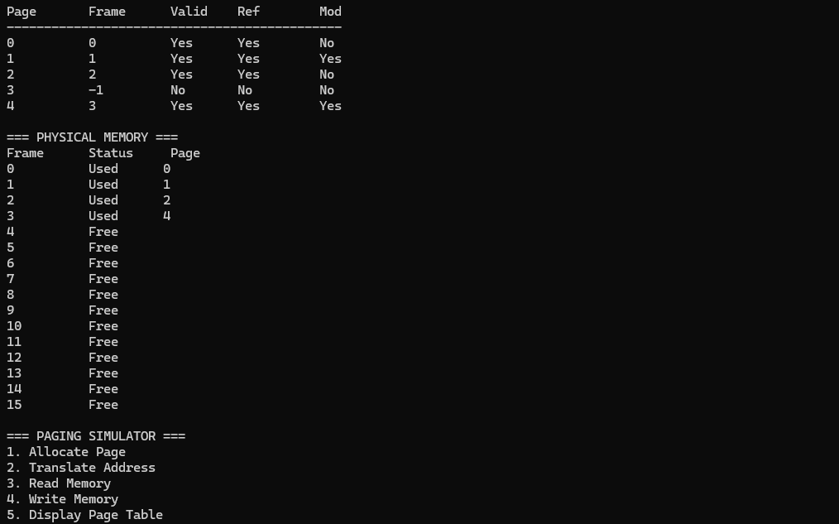
1.4
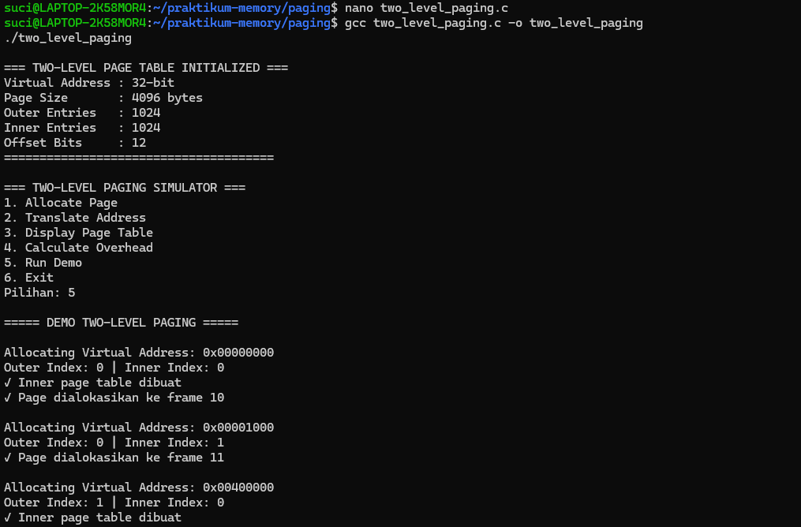
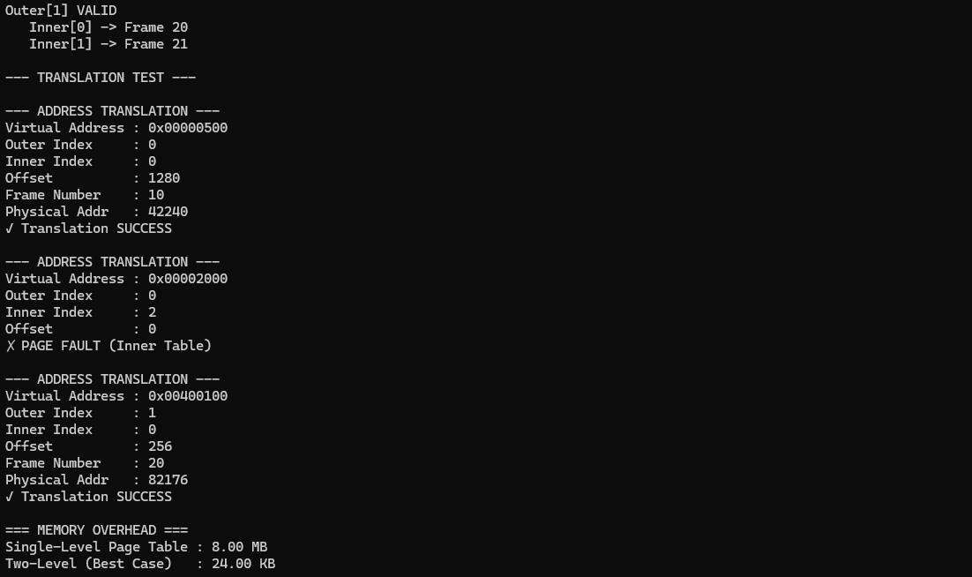

1.5
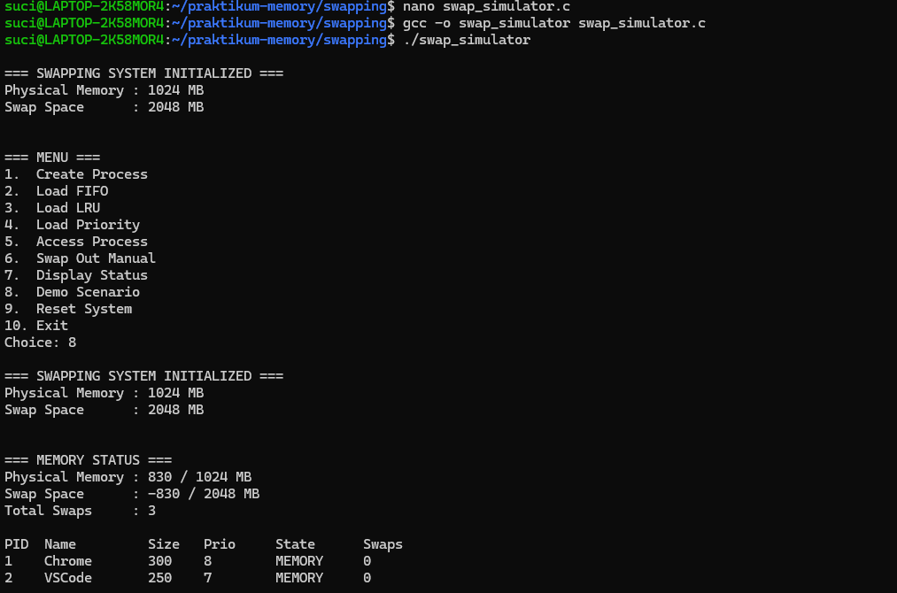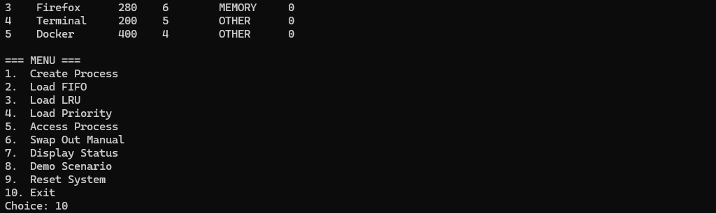
1.6
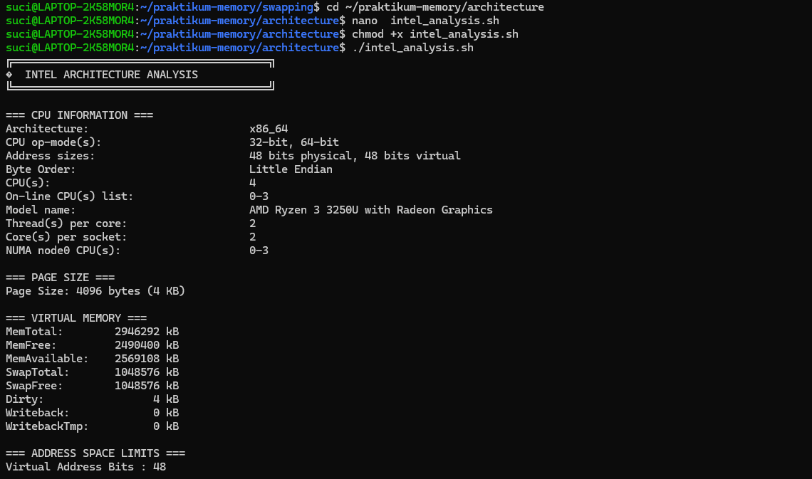
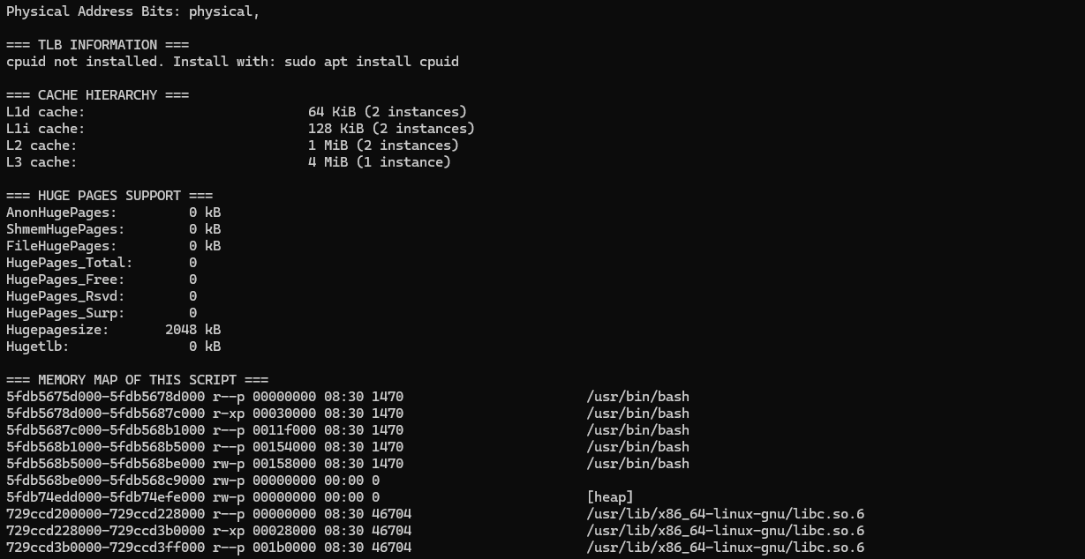
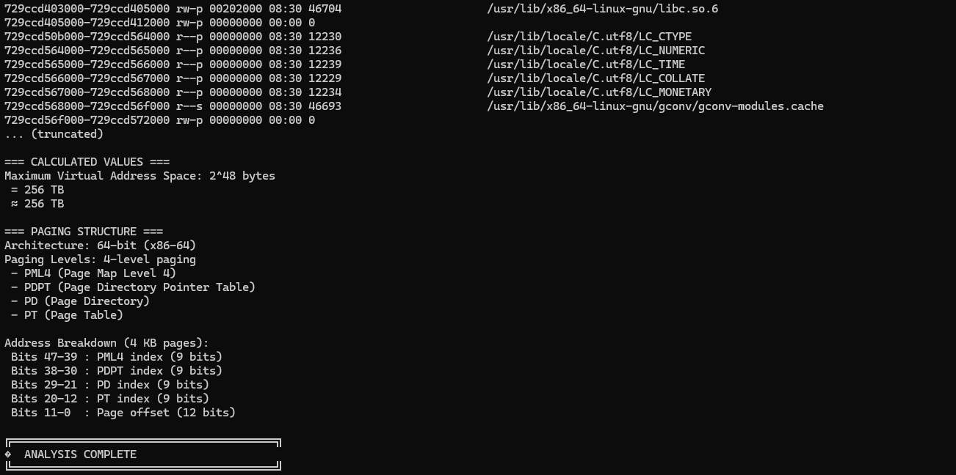
1.7
